

development diary 6

Professional Practice for Game Design – CMP4271

interview and sales pitch



30th of november 2020

By

Sean Colbourne

4.1 Premise

Interviews were performed with roles switching between being the client and the clientele, the aim of this as an employer was to retrieve the necessary information of what a client could do for the company whilst also gathering information such as the price of the project, how the money was to be made and the time frame this would be done in.

On the other hand, when interviewed as a client to avoid mistakes such as telling the employer information that could be potentially jeopardise the chance of getting funded, so they had to wait for a question before being able to give a clear answer.

A game idea was then created and pitched based on the information that was gathered during the interview phase, the teams where then informed weather or not they would get funding for the project proposal.

4.2 Rules

Although no rules were implemented it was required to be for an audience between the ages of fifteen to eighteen and help prospective students to the university (employer), whilst also being a point and click premise there was also minigames that had to be implemented

4.3 Material’s

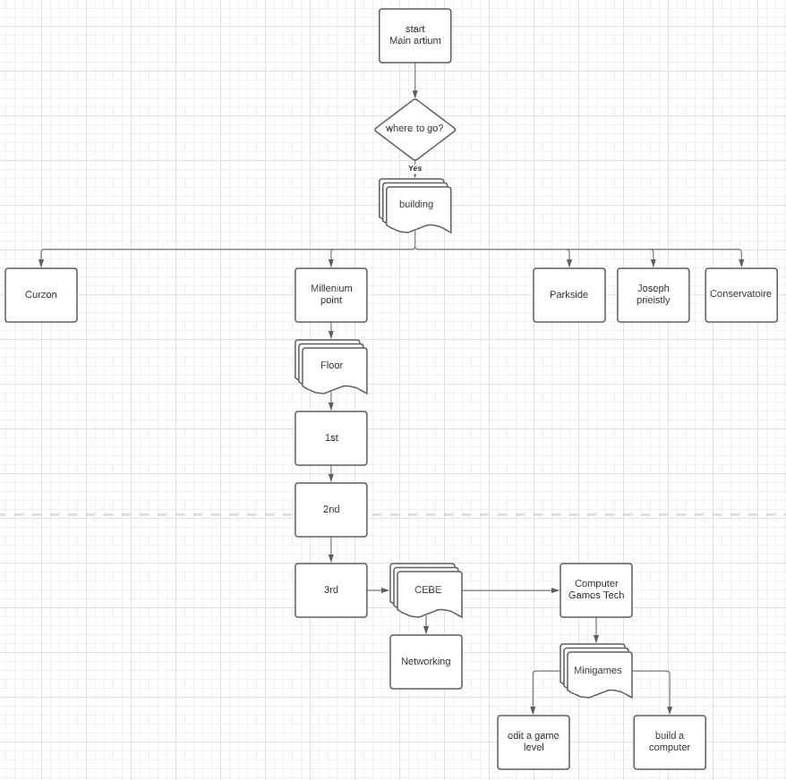

Figure 1, this flow diagram shows how the game would flow from scene to scene.

Software

Google slides was used to create a presentation, that was then later pitched to an employer, lucid chart was also used, this was to create a flow diagram that gave the employer a visual representation of how the game work.

Microsoft Teams was also used to allow ease of communication and document sharing meaning that the project could be discussed before being put in motion.

4.4 How it’s played

The premise of the game was to be a point and click interactive website, players used their mouse if on a personal computing device and used touch input if on a touch supported device to decide where to go in the game.

Play testing

Play testing was not available as this was an idea for a game, however a sales pitch and mock interview had taken place giving an realistic example of what being in an interview with an employer trying to get funding was like, whilst also showing how to conduct an interview if the need arises.

4.5 Teamwork experience

The biggest experience gained from this task was that interviewing potential clients requires a lot of planning for the questions to be asked, and having a team helping plan these would be a necessity for a successful interview.

4.6 Reflection

Upon completion of this task I have found that it would have been better to start the flow diagram as early as possible so that you have a visual representation of an idea rather than attempting to describe an idea without visual aides.